Python OOPS Concepts
OOP stands for Object-Oriented Programming. Python is an object-oriented programming language. It allows us to develop applications using Object Oriented approach. In Python, we can easily create and use classes and objects.
Major principles of object-oriented programming system are given below:-
- Object
- Class
- Method
- Inheritance
- Polymorphism
- Data Abstraction
- Encapsulation

Object
Object is an entity that has state and behavior. It may be anything. It may be physical and logical. For example: mouse, keyboard, chair, table, pen etc.
Everything in Python is an object, and almost everything has attributes and methods. All functions have a built-in attribute __doc__, which returns the doc string defined in the function source code.

Class
Class can be defined as a collection of objects. It is a logical entity that has some specific attributes and methods. For example: if you have an employee class then it should contain an attribute and method i.e. an email id, name, age, salary etc.
Syntax
class ClassName:
<statement 1>
.
.
.
<statement - N>

Method
Method is a function that is associated with an object. In Python, method is not unique to class instances. Any object type can have methods.

Inheritance
Inheritance is a feature of object-oriented programming. It specifies that one object acquires all the properties and behaviors of parent object. By using inheritance you can define a new class with a little or no changes to the existing class. The new class is known as derived class or child class and from which it inherits the properties is called base class or parent class.
It provides re-usability of the code.

Polymorphism
Polymorphism is made by two words "poly" and "morphs". Poly means many and Morphs means form, shape. It defines that one task can be performed in different ways. For example: You have a class animal and all animals talk. But they talk differently. Here, the "talk" behavior is polymorphic in the sense and totally depends on the animal. So, the abstract "animal" concept does not actually "talk", but specific animals (like dogs and cats) have a concrete implementation of the action "talk".

Encapsulation
Encapsulation is also the feature of object-oriented programming. It is used to restrict access to methods and variables. In encapsulation, code and data are wrapped together within a single unit from being modified by accident.

Data Abstraction
Data abstraction and encapsulation both are often used as synonyms. Both are nearly synonym because data abstraction is achieved through encapsulation.
Abstraction is used to hide internal details and show only functionalities. Abstracting something means to give names to things, so that the name captures the core of what a function or a whole program does.

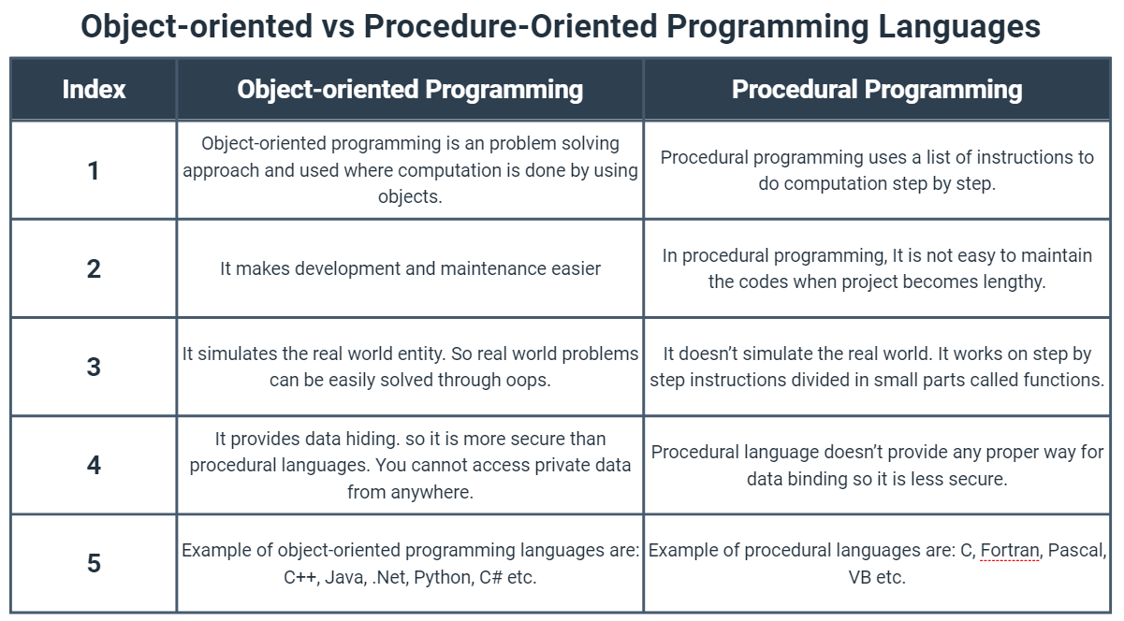

Python Object
Python is an object oriented programming language. So, its main focus is on objects unlike procedure oriented programming languages which mainly focuses on functions.
In object oriented programming language, object is simply a collection of data (variables) and methods (functions) that act on those data.

Python Class
A class is a blueprint for the object. Let's understand it by an example:
Suppose a class is a prototype of a building. A building contains all the details about the floor, doors, windows, etc. we can make another buildings (as many as we want) based on these details. So building is a class and we can create many objects from a class.
An object is also called an instance of a class and the process of creating this object is known as instantiation.
Python classes contain all the standard features of Object Oriented Programming.

Define a class in Python: In Python, a class is defined by using a keyword class like a function definition begins with the keyword def.

Syntax
class ClassName:
<statement 1>
.
.
.
<statement-N>
A class creates a new local namespace to define its all attributes. These attributes may be data or functions.
Example

Python Objects of Classes 1
There are also some special attributes that begins with double underscore (__). For example: __doc__ attribute. It is used to fetch the docstring of that class. When we define a class, a new class object is created with the same class name. This new class object provides a facility to access the different attributes as well as to instantiate new objects of that class.
Python Objects of Classes 2
Create an Object in Python.
We can create new object instances of the classes. The procedure to create an object is similar to a function call.
Let's take an example to create a new instance object ob. We can access attributes of objects by using the object name prefix.
Example
Python Class Constructors
A constructor is a special type of method (function) which is used to initialize the instance members of the class. Constructor can be parameterized and non-parameterized as well. Constructor definition executes when we create object of the class. Constructors also verify that there are enough resources for the object to perform any start-up task.
Creating a Constructor
A constructor is a class function that begins with double underscore (_). The name of the constructor is always the same __init__().
While creating an object, a constructor can accept arguments if necessary. When we create a class without a constructor, Python automatically creates a default constructor that doesn't do anything.
Every class must have a constructor, even if it simply relies on the default constructor.

Python Constructor Example (Non-Parameterized)
Let's create a class named MyOwnClass, having two functions __init__() function and sayHello() to display Hello message.
Python Constructor Example (Parameterized)
Let's create a class named MyAddition, having two functions __init__() function to initialize the variable and getAddition() to display the sum of number properly.

Python Inheritance
What is Inheritance?
Inheritance is a feature of Object Oriented Programming. It is used to specify that one class will get most or all of its features from its parent class. It is a very powerful feature which facilitates users to create a new class with a few or more modification to an existing class. The new class is called child class or derived class and the main class from which it inherits the properties is called base class or parent class.
The child class or derived class inherits the features from the parent class, adding new features to it. It facilitates re-usability of code.
Example
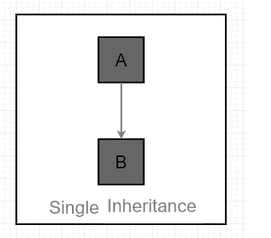
Python Inheritance Syntax
class DerivedClassName(BaseClassName):
<statement-1>
.
.
<statement-N>
Python Multilevel Inheritance
Multilevel inheritance is also possible in Python like other Object Oriented programming languages. We can inherit a derived class from another derived class, this process is known as multilevel inheritance. In Python, multilevel inheritance can be done at any depth.
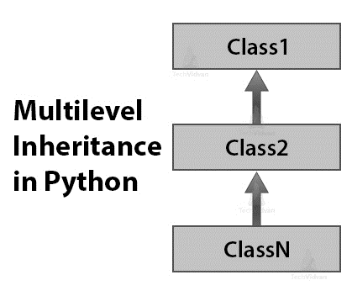

Python Multiple Inheritance
Python supports multiple inheritance too. It allows us to inherit multiple parent classes. We can derive a child class from more than one base (parent) classes.
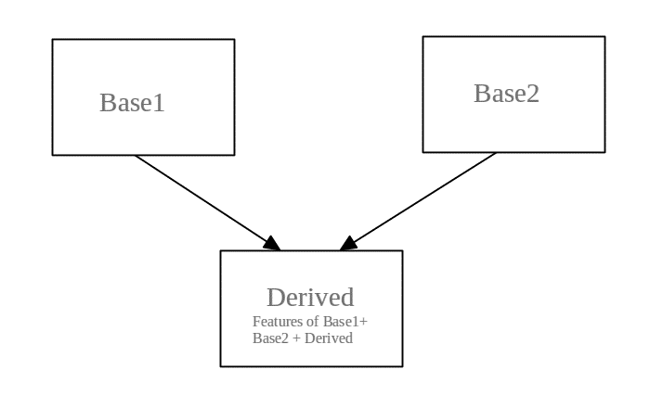

Python Hierarchical Inheritance
When more than one derived classes are created from a single base this type of inheritance is called hierarchical inheritance. In this program, we have a parent (base) class and three child (derived) classes.
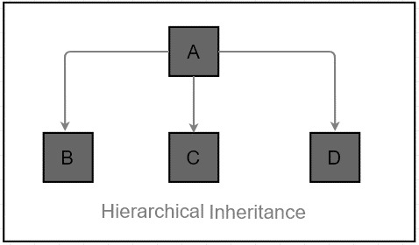
Python Hybrid Inheritance
Hybrid inheritance is a combination of multiple inheritance and multilevel inheritance. The class is derived from the two classes as in the multiple inheritance. However, one of the parent classes is not the base class. It is a derived class.
